**Admin:** The Admin category is located at the top of the main menu panel.  Selecting it allows you to access the Admin sub-menu and change not only your settings, but those of all the NetView Desktop users using your version of the program.  **NOTE:** **You must be set as an administrator in your profile settings in order to view this category.** This is the only Settings category that is restricted to system administrators. All other users can access the remaining 3 categories.

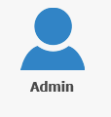

**Security—Security & Password Policy:** The Security heading is located at the top of the sub-menu panel.  It indicates which applications can be used to alter the security settings.

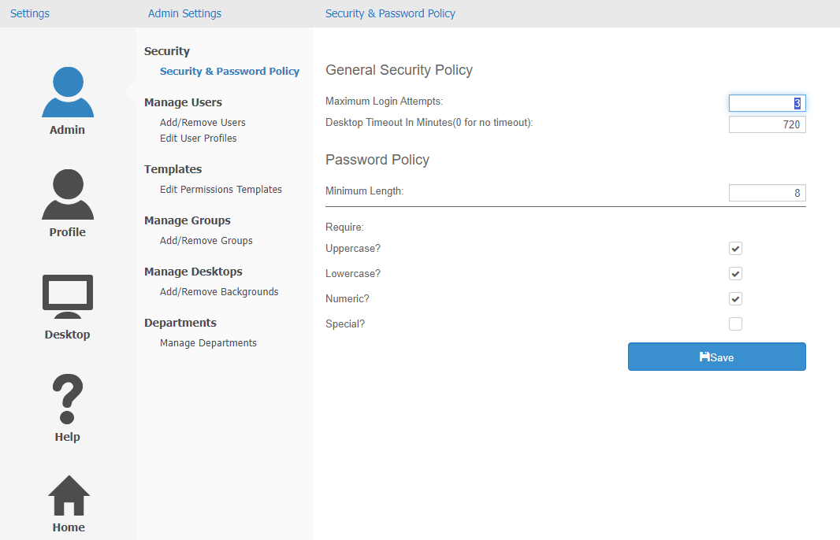

Currently there is only one Security screen, “Security & Password Policy.” This screen lets you adjust the security and password policies for all users.

General Security Policy: These options let you adjust general security options to help prevent unauthorized users from accessing the server.

**Maximum Login Attempts:** This field allows you to set the maximum number of times someone can attempt to log in to NetView Desktop before the system temporarily locks them out. You must put a number of **1 or higher** in the field; you cannot leave it blank or set to 0.

**Desktop Timeout:** This field allows you to set the length of time the program will keep a user logged in until it “times them out,” or automatically logs them off. The timeout is set in **minutes**. **NOTE:** If you do not want to have a timeout, enter “0” in this field.

Password Policy: These options let you set requirements for NetView Desktop user passwords in order to make it more difficult for an unauthorized user to guess the password.

**Minimum Length:** The space allows you to set the minimum length of the user password.  This requires all users to create passwords that are at least a certain length. Per HBS Systems requirements, the minimum password length must be **8 characters or more**.

**Other Requirements:** This section allows you to add or remove other requirements to user passwords. If you do not wish to have any other requirements attached to your passwords, leave all the boxes **unchecked**.

* **Uppercase:** Check this box to force users to include at least 1 uppercase alpha character in their password.
* **Lowercase:** Check this box to force users to include at least 1 lowercase alpha character in their password.
* **Numeric:** Check this box to force users to include at least 1 numeric character in their password.
* **Special:** Check this box to force users to include at least 1 special character in their password. **NOTE:** Special characters include “@, #, $, %, *, &,” etc.

**Manage Users:** The Manage Users heading is situated below the Security options.  It allows you to edit user accounts and profiles.

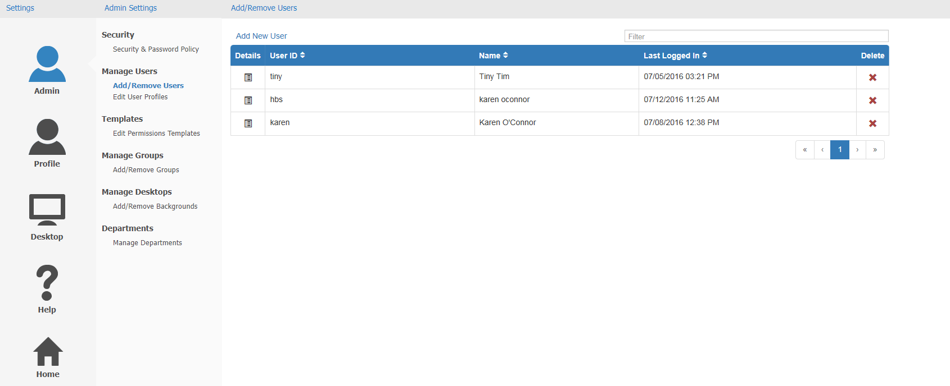

Add/Remove Users: Each row in the grid contains the basic information for each user with access to your NetView Desktop: their user ID, their name, and what date and time they last logged in.

**Switching Pages:** The page numbers are listed below the lower right-hand corner of the grid.  The square representing the current page will be colored blue.  The page list shows how many pages of user entries there are, and offers a number of features for moving between pages.

* **Single Page Scroll:** Click the single arrows to move a single page. If one of the arrows turns grey, then you cannot scroll forward or back from that page (depending on which arrow turned grey).
* **First & Last Scroll:** The First & Last scroll buttons are the double arrows at both ends of the page list.  They allow you to move from any results page to either the very first results page or the very last.
  + Click on the left-pointing double arrows to go to the first page.
  + Click on the right-pointing double arrows to go to the last page.
* **Page Buttons:** You can also switch between pages by clicking on a page number.  For example, to go to page 2, click on “2.”

**Filter Bar:** The Filter Bar is located in the upper right-hand corner of the result page. By typing information into it, you can further narrow down your results to find the entry you want. The feature will provide results for even partial information, like part of a name or the numbers representing the month in the date entry. **NOTE:** The bar will search for the exact sequence of letters or numbers you type in across all headers, reading from left to right across the rows. This means that if you typed in “t 07/29,” you could get results back where the last letter of the person’s name is “t” and they last logged in on July 29th.

**User Details:** The Details column is on the far left of the grid.  Clicking the icon in the column will take you to the Edit User Profiles page for that row's user.  See the “**Edit User Profiles**” section below for how to use that page to edit a user’s profile information.

**Delete:** The Delete column is on the far right of the grid, and each square in the column has a red “x” icon.  Click the “x” to delete the user’s profile. A dialog box will appear, asking if you are sure you want to delete the user.  Click **Yes** to delete the user’s profile and remove their access to NetView Desktop.

**Add New User:** The Add New User feature is located at the upper left-hand corner of the panel. Click the link to open the following window:

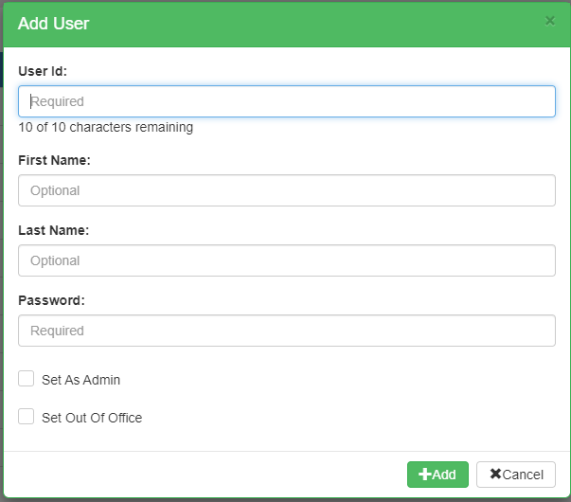

Enter the new user’s information.  You can also set the user as an administer if you desire. Click the **Add** button to create the user.

Edit User Profiles: The Edit User Profiles panel allows you to view and edit an individual user’s profile information.

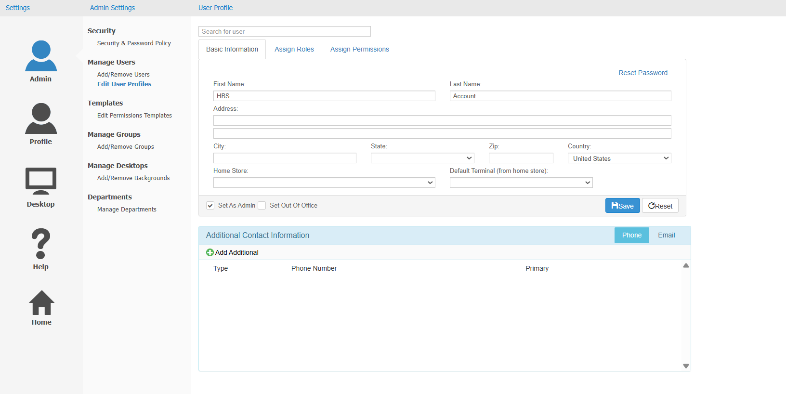

**Search for User:** The Search for User bar is located in the upper left-hand corner of the panel. To search for a user profile, type in the desired user name.  A drop-down selection of possible users will appear below the bar. Either type in the user’s full name and press the “Enter” key, or select the user’s name from the dropdown. The user’s information will then fill in the profile page.

**Basic Information Tab:** This tab shows the selected user's basic profile information, such as their name, address, home store/business division location, and, if their home location has SmartIron credit card processing set up, their default SmartIron card terminal.  As the system administrator, you can edit all active fields in the profile as necessary.

* **Basic Information Box:** This section of the tab holds the user’s main profile information as described above, as well as additional settings for the user.
  + **Reset Password:** The words “Reset Password” are displayed in blue above the upper right-hand corner of the Basic Information box.  Click this link to reset the selected user’s password. The following window will open:

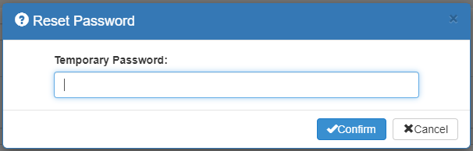

Enter a temporary password and click **Confirm** to reset the password. The user will be made to enter a new password the next time they log in to the system.

* + **Set As Admin:** This box is located in the bottom left-hand corner of the Basic Information box. Check the box and click **Save** to set the user as an administrator.
  + **Set As Out of Office:** Check this box if the user will be out of office for a considerable amount of time.  This lets the system know that the user will not be available to address any messages requiring immediate action, so it will send notifications to other users who could do the job instead. Make sure to **remove** the check when the user returns so the system knows you are back. **NOTE:** This process should normally be carried out **by the user,** but you as the system administrator have the capability to do it for them if they forget.
  + **Save:** Click this button to save any changes made to fields in the Basic Information box.
  + **Reset:** If you make changes in the Basic Information box, but don't want to save them, click this button to reset the fields to how they were before you made changes.  Be sure to click “Save” AFTER you click "Reset."
* **Additional Contact Information:** The Additional Contact Information box is below the Basic Information box.  You can use it to add or remove the user’s phone numbers and email addresses.
  + **Phone:** To view the user’s contact phone numbers, select the Phone tab.  A list of phone numbers, along with each number’s “type” (work, home, mobile, etc.), will appear in the box.  The box will also indicate which number is the user’s primary phone number.
    - To add a phone number to the user’s contact list, click **Add Additional**. The following window will open:

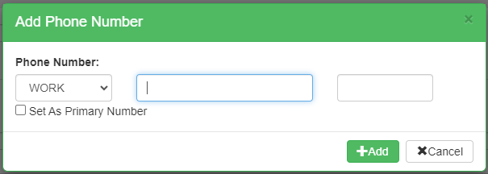

* + - * Select the phone number’s desired type from the drop-down menu in the first field.
      * Type the phone number into the second field.
      * If there is an extension, type that into the second field.
      * To set the new number as the user’s primary contact, check **Set As Primary Number**.
      * Click the **Add** button to add the new number.
    - To edit an existing phone number, click the **Edit** icon () next to the number to open the following window:

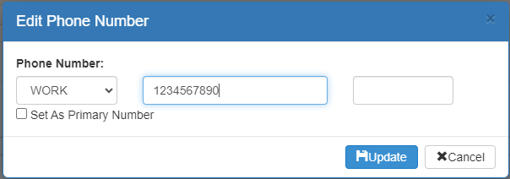

Make changes as desired, then click **Update** to save them.

* + - To remove a phone number on the user’s contact list, click the black **“x”** on the same line as the number. A dialogue box will appear, asking if you really want to remove the number.  Click **Yes** to delete the number.
  + **Email:** To view the user’s contact email addresses, select the Email tab.  A list of email addresses, along with each address’s “type” (home, work, etc.) will appear in the box.  The box will also indicate which address is the user’s primary email. **NOTE:** The user **requires** at least 1 primary email address in order to use the SupportNow Chat feature on the main Desktop.
    - To add an additional email address to the user’s contact list, click **Add Additional.** The following window will appear:

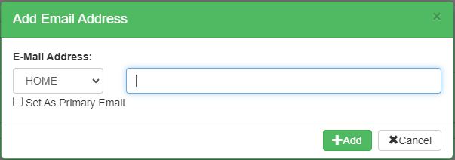

* + - * Select the address’s desired type from the drop-down menu in the first field.
      * Type the email address itself in the second field.
      * To set the new email as the user’s primary contact email, check **Set As Primary Email**.
      * Click the **Add** button to add the new number.
    - To edit an email address on the user’s contact list, click the click the **Edit** icon () next to the address to open the following window:

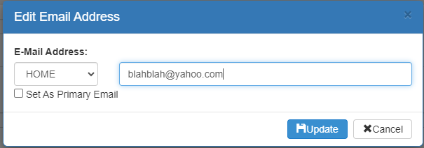

Make changes as desired, then click **Update** to save them.

* + - To remove an email address from the user’s contact list, click the black **“x”** on the same line as the address. A dialogue box will appear, asking if you really want to remove the address.  Click **Yes** to delete the address.

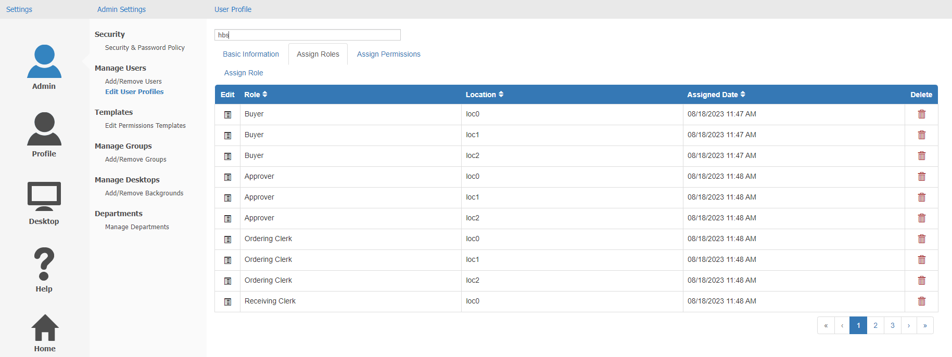

**Assign Roles:** This tab allows you to view and manage the user's roles.  A role is basically a set group of permissions that can be assigned to a user to allow them to perform certain actions within a specific category of programs.  They are primarily assigned by department and dealer location. As the system administrator, you must add, edit, and delete user roles as necessary.

At the moment, the only program that actually utilizes roles is **Integrated Purchase Orders (IPO)**.  See the **IPO Roles Setup** topic for detailed information on the IPO roles and how to manage them using this screen.

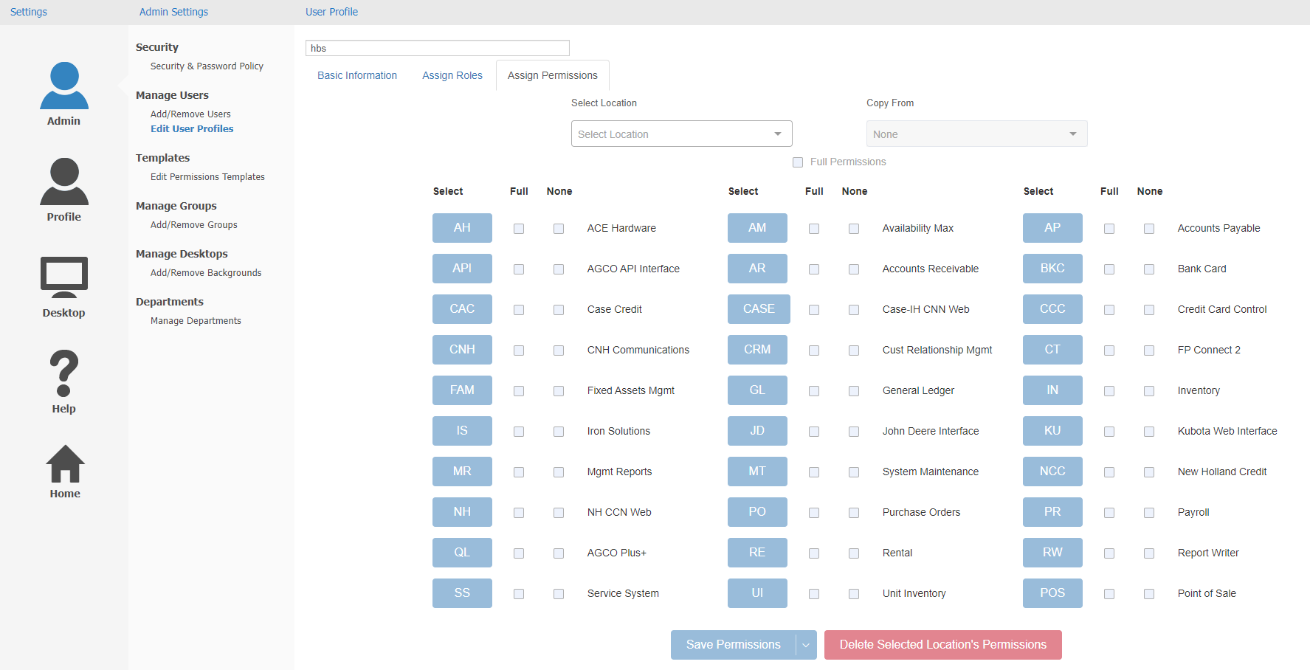

**Assign Permissions:** This tab allows you to create and modify permissions for each of your users. It replaces the previous Permissions program, which had a shortcut of PERM, in order versions of the software. User permissions are maintained on a location-by-location basis, and are split out into various modules, represented by each of the buttons under the “Select” column (AP is Accounts Payable, AR is Accounts Receivable, IN is Inventory, etc.).

* **Select Location:** Begin by selecting an ActiveDesktop location from this dropdown. This will let you view/modify the user’s permissions at this specific location. You can select **more than one** location at a time to modify permissions for, provided you have more than one location set up in ActiveDesktop. If your dealership is a **single-location**, then only that location will be available for selection. Multi-location dealerships will have more than 1 option available here.
  + If you want to choose multiple locations and their existing permissions are **not the same**, each time you add a new location whose permissions differ from those currently displayed you will see a modal asking which location you want to display and modify:

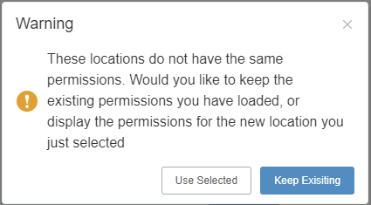

* + - Click **Use Selected** to show the newly-selected location’s permissions.
    - Click **Keep Existing** to retain the previous-selected location’s permissions.

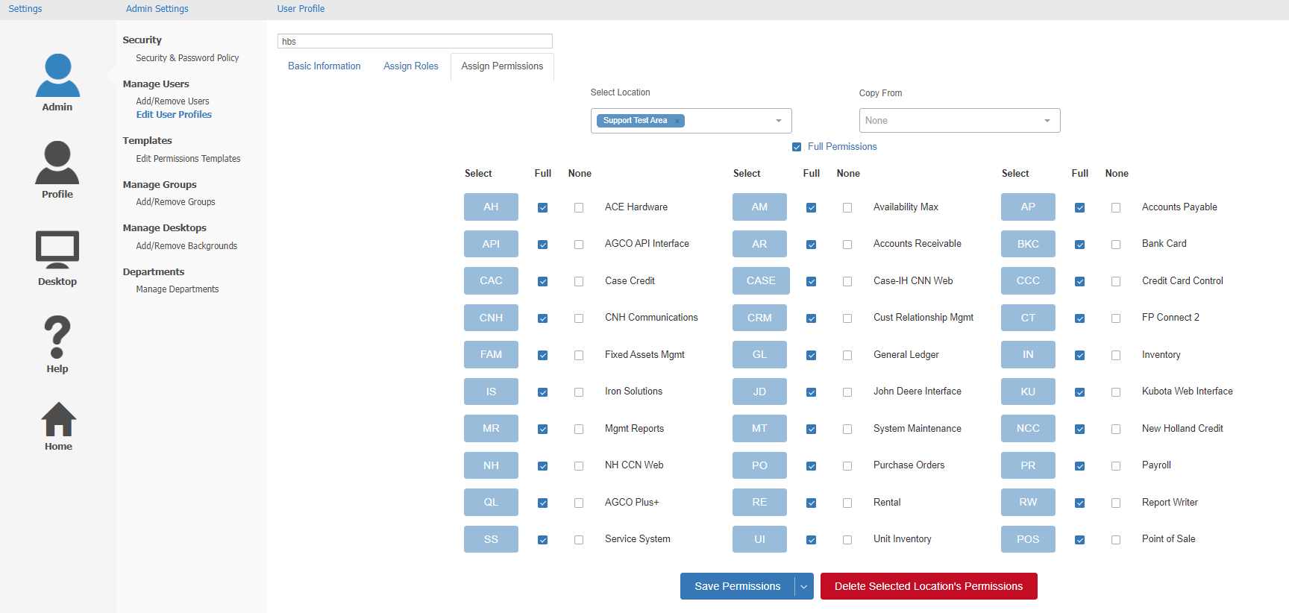

* **Copy From:** This feature allows you to implement an existing set of permissions for a user, which in the case of a new user can make adding them to the system much faster. Use this dropdown to select either an existing user’s permissions set for a specific location, or a permissions template you have created in the “Edit Permission Templates” screen (**see the “Templates” section below for more information**). The selected permissions will automatically overwrite anything currently displayed on the screen, allowing you to then make any adjustments before saving them for the user.
* **Setting Full User Permissions:** If you want the user to have **full** permissions for **everything** in the system, check the box next to **Full Permissions**. For anything less than full permissions, you will have to specify which modules, programs, and functions you want the user to be able to access.
  + If you want the user to have full permissions for a particular module, check the box under the **Full** column next to the module’s designated button.
  + If you want to **block** the user from using any program or function within a particular module, check the box under the **None** column next to the module’s designated button.
  + If you want to drill into the specific programs and functions within a module to assign your user’s permissions, click on the module’s button. A screen like the following will open (example below is the AP module’s screen):

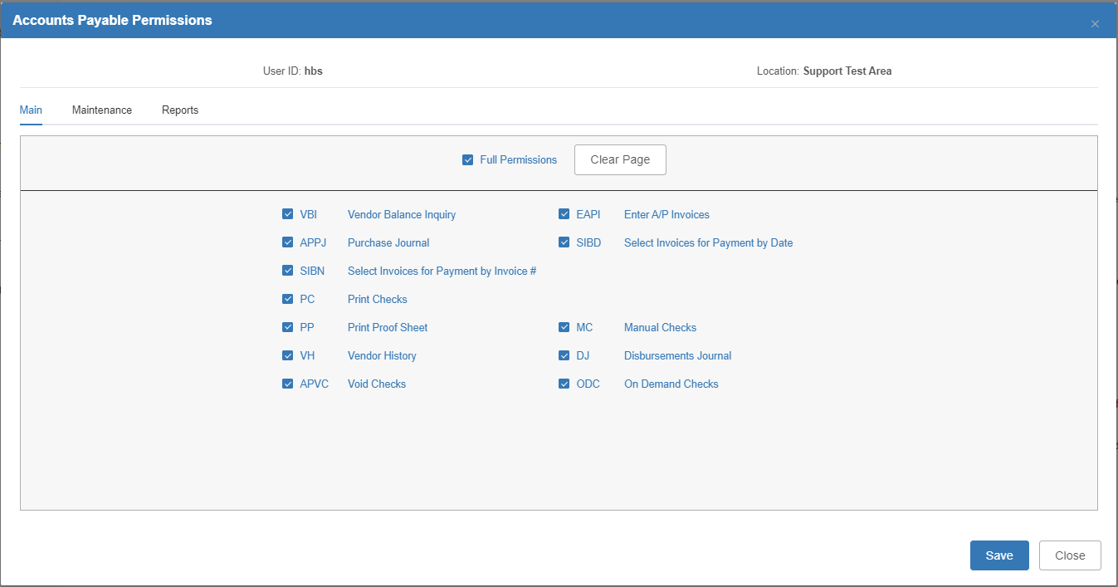

Go through the available tabs and modify the permissions as you wish. Each tab is a grouping of similar programs or functions within the module. Check the box next to each program or function you want to enable. **NOTE:** Some of the permissions are dependent upon each other, so watch out for associated boxes.

* + - You can check a “Full Permissions” box for each available tab.
    - You can click **Clear Page** to automatically clear all checks on a specific tab, thus removing all the permissions at once.
    - Click **Save** to save your settings before returning to the main screen, where you **will** need to still save all the user’s permissions overall to actually lock these choices in.
* **Save Permissions:** Once you have the user’s permissions set as desired for the selected location(s), click this button to save the settings.
  + **Save & Create Template:** If you also want to save this particular set of permissions as a template to be reused for other users, you can click the arrow next to the button and click **Save & Create Template.** A window will open to allow you to name and save the template:

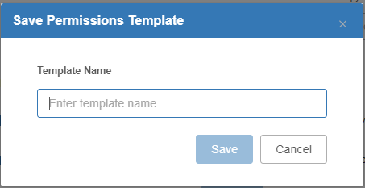

* **Delete Selected Location’s Permissions:** If you want to remove the user’s permissions for one or more locations, select the location(s), then click this button at the bottom of the screen. The following alert will appear:

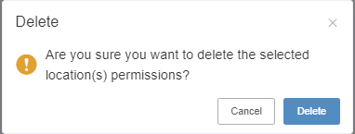

Click **Delete** to delete the permissions. The user’s permissions at the location(s) will automatically be removed, represented by all the boxes in the **None** columns being checked for each module.

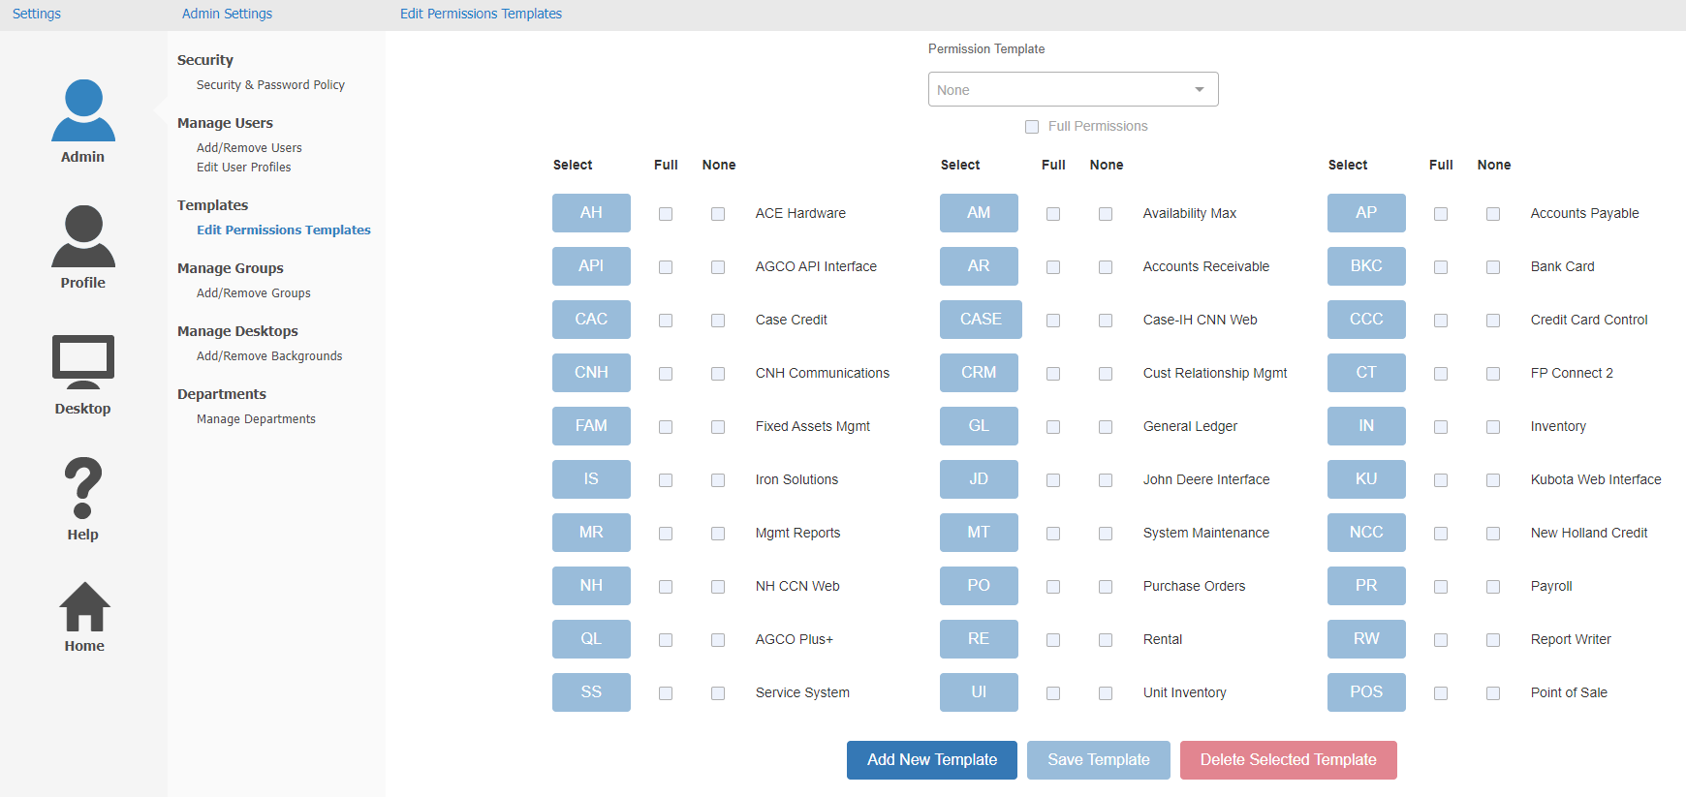

**Templates—Edit Permissions Templates:** This screen, added as a new supplement to user permissions, allows the user to create and modify permissions templates that they can then auto-assign to new users.

Add New Template: To add a new permission template, click this button at the bottom of the screen. The following window will open:

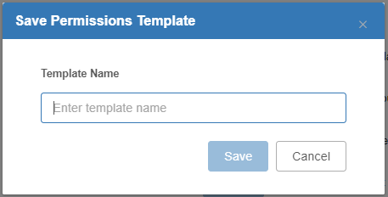

Enter a name for the template that will distinguish it from your other templates, then click **Save**. The window will close and the screen will activate so you can select the desired permissions for the template.

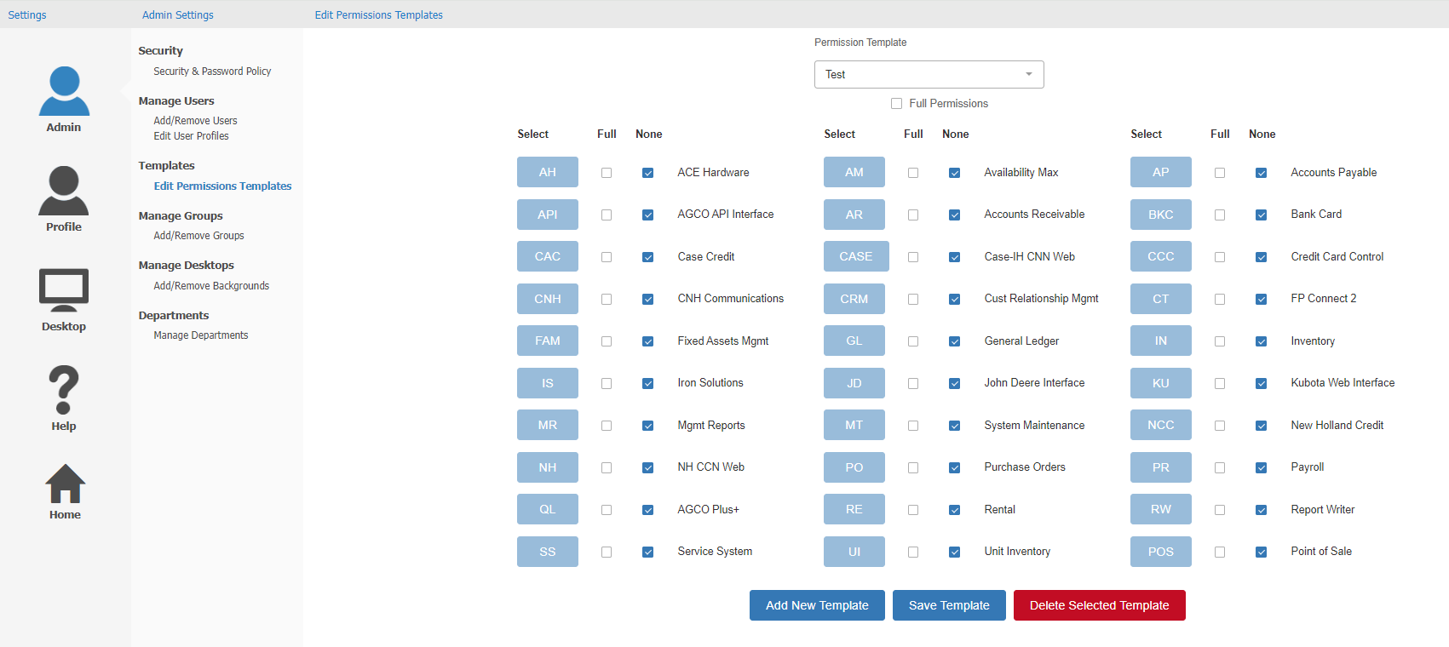

Choose permissions as you would on the User Profile’s “Assign Permissions” screen, then click **Save Template** to save the new template.

Editing a Template: To edit an existing template, select the template from the “Permission Template” drop-down menu at the top of the screen. The selected template will populate the screen, and you can made adjustments as needed. Click **Save Template** to save your changes.

Deleting a Template: To delete an existing template, select the template, then click **Delete Selected Template.** The following window will appear:

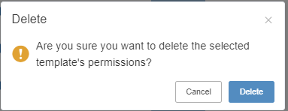

Click **Delete**. The window will close and the template will be deleted, resetting the screen back to a blank default.

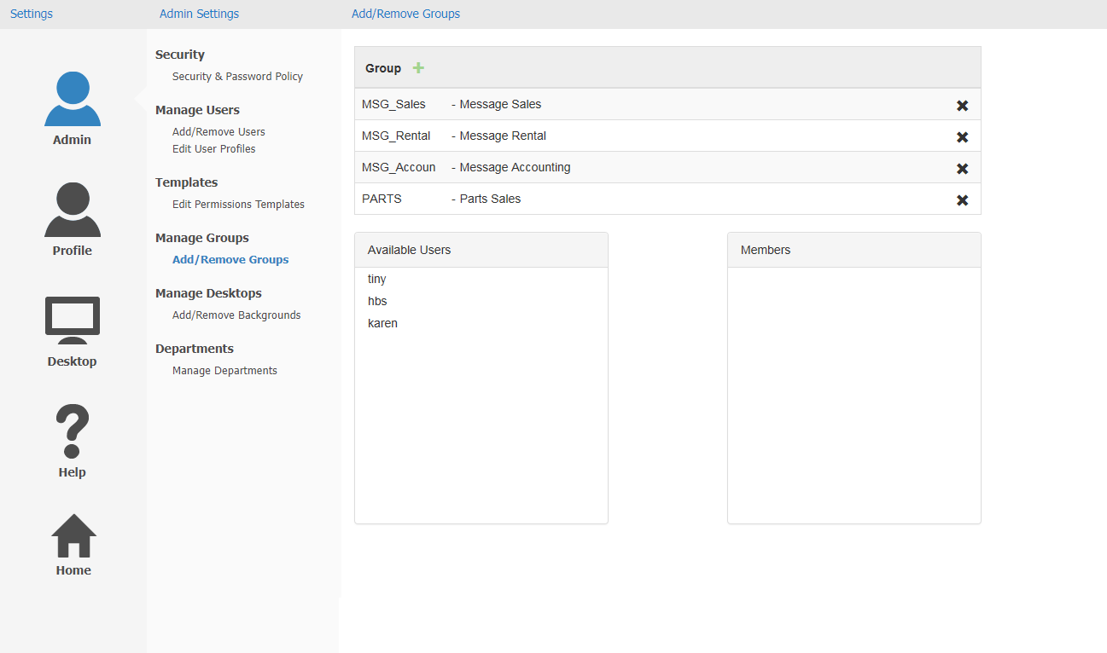

**Manage Groups—Add/Remove Groups:** The Manage Groups heading is situated below the Manage Users options.  It can be used to change the groups associated with NetView Messaging’s group message feature (see the **Messaging** topic for more information).

The Add/Remove Groups screen is the only one available under the heading. It displays both a list of the different messaging groups and a list of all the users who could be included in those groups. There is also a box titled “Members,” which will display the users included in a group.

View Group: To see which users are members of a group, select the desired group by clicking on it.  The current members of the group will then display in the “Members” box.

Create Group:To create a new group, click the green “+” in the “Group” box’s header. The following window will open:

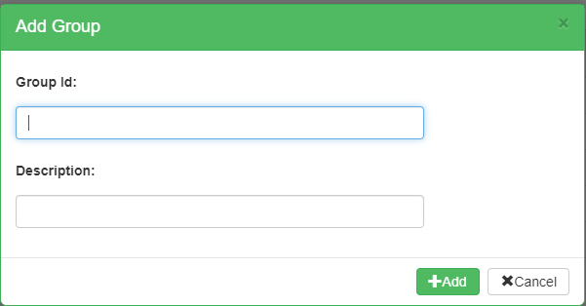

Enter a group ID and description, then click **Add** to create the new group.

Delete Group:To delete a group, click the black “**x**” next to each group on the list. The following window will appear.:

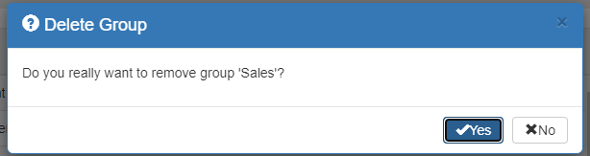

Click **Yes** to remove the group. It will then disappear from the list.

Adding Members:To add members to a group, select the desired group by clicking on it, which will highlight it in blue.  The current members of the group will display in the “Members” box. Click a user’s name in the “Available Users” box, then drag and drop it into the “Members” box using the mouse.

Removing Members: To remove a member from a group, select the desired group by clicking on it.  The current members of the group will display in the “Members” box. Click the black “**x**” to the right of the member’s name. The following window will appear:

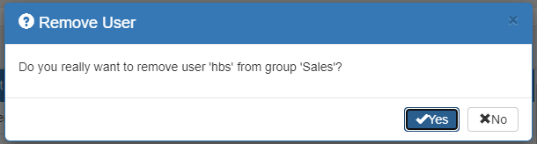

Click **Yes** to remove the user. Their ID will disappear from the “Members” box.

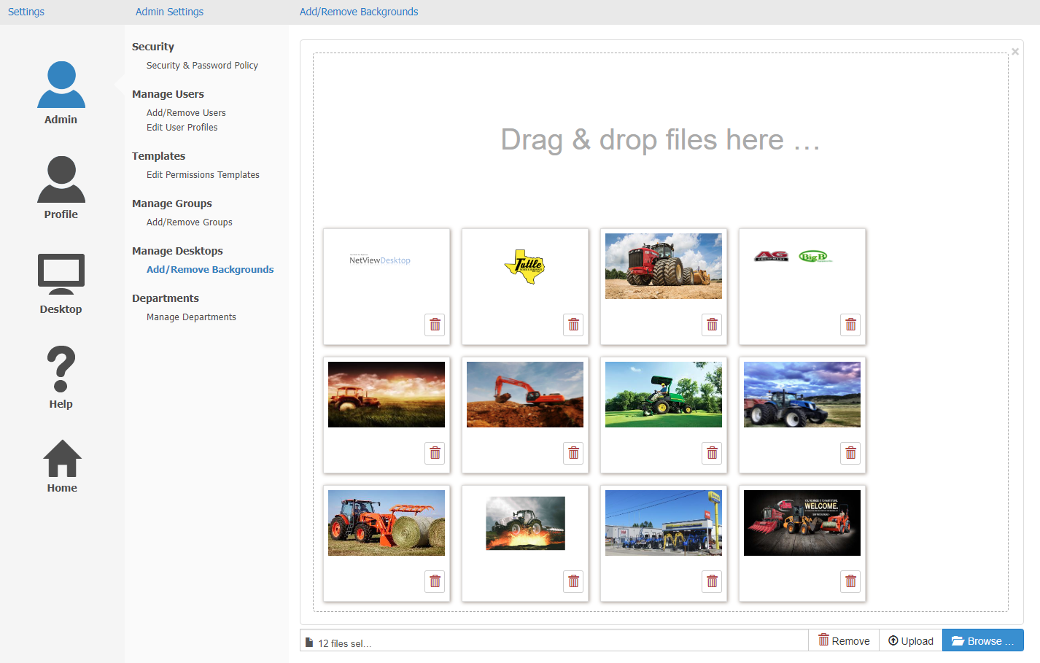

**Manage Desktops—Add/Remove Backgrounds:** The Manage Desktops heading is situated below the Manage Groups options.  It can be used to add or remove background options from NetView Desktop.

The Add/Remove Backgrounds screen displays all available background options for NetView Desktop, as well as features to add new options and remove current ones.  The total number of background options is displayed in a bar on the lower left-hand corner of the panel, next to an icon of a page, and should read “(number) files selected.” **NOTE:** Only a system administrator can make changes to the background library by adding or removing images.

Add New Background: You can add a new background image one of two ways:

**Drag-and-Drop:** Open the file location on your computer that holds the image file you want to add. Click the file and then, while holding down the mouse key, drag and drop the image into the panel on the screen. It will immediately be added to the available image files.

**Browse:** Click the **Browse** button at the bottom of the panel. It will open your file browser for you. Locate the image file, then either click the “Open” button in the browser window or double-click on the picture.  The image will then add to the panel.

Upload Background: At this point a downward-pointing finger will appear in the lower left-hand corner of the picture, indicating it has not been uploaded to NetView ActiveDesktop yet. To upload the image file to NetView Desktop, either:

* Select the image and click the **Upload** button.
* Click the “Upload” icon attached to the image (the pointing finger).

Remove Background: To remove a background option, click the **Remove** icon attached to the picture (will look like a red trash can). To remove **all** background options, click the **Remove** button at the very bottom of the screen.

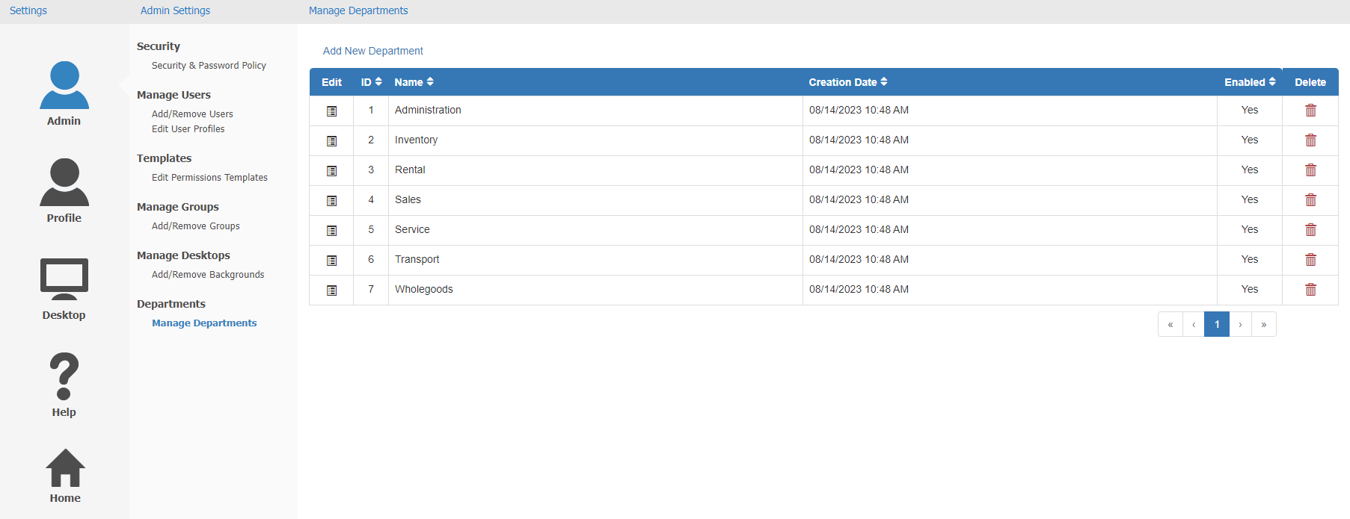

**Departments—Manage Departments:** This final screen allows you to manage and create departments for user roles. These ideally represent actual departments at your dealership, so you can set your employees' roles to better reflect their actual duties within their departments.

Department Grid: Every available role department made on your system will appear in this grid. Make sure when setting up your system that you include all of your various departments here to make defining user roles easier. Each department entry will show the following information:

**Edit:** Click the icon in this column to edit the department information.  The following window will appear:

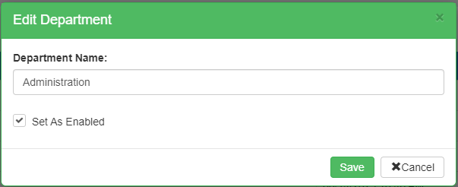

* **Department Name:** This field holds the department name.
* **Set As Enabled:** Check this box to enable, or activate, the department for use. This box **must** be checked in order for the department to appear as an option when setting roles and creating purchase orders.
* **Save:** Click this button to save your changes.
* **Cancel:** Click this button to close the window without saving.

**ID:** This column shows the department’s ID number, which is assigned by the system when the department is created.  This number is for system-tracking purposes; it will never change and cannot be edited.

**Name:** This column shows the department name.

**Creation Date:** This column shows the date and time the department was created.

**Enabled:** This column indicates whether or not the department is currently enabled.

* If the column reads **Yes**, the department is currently enabled.
* If the column reads **No**, the department is disabled and unavailable for use.

**Delete:** This column holds the Delete icon for the department entry. It will only activate if the department is **disabled** and has **never** been assigned to any user role in use on any document recorded in the system (historical documents included). Click on it to delete the department from the system.  The following warning will appear:

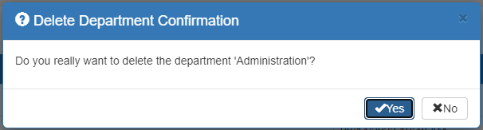

Click **Yes** to delete the department.

**NOTE ON DEPARTMENT GRID:** If for any reason the grid display is too large for your monitor or laptop screen, some of the columns will be **hidden** in order to fit the grid in the display.  If any columns have been hidden, a “**+**” icon will appear next to the **Edit** icon.  Click it to view any hidden column data, and click it a second time to re-hide the data.

Add New Department: Add departments to the grid using the Add New Department feature.  Click “Add New Department” above the grid to open the following window:

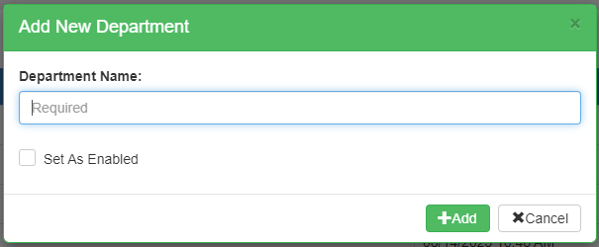

Enter the department name and click “Set as Enabled” to make it active, then click **Add**. The new department will then appear in the Department Grid listing and be available for roles and purchase orders.